**MINI PROJECT**

**(2020-2021)**

**Medical Based Web Application**

**MID-TERM REPORT**



**Institute of Engineering & Technology**

**Submitted by**

**Kartik Agrawal (181500310)**

**Kush Mittal (181500342)**

**Mukund Agrawal (181500401)**

**Ashish Agrawal (181500137)**

**Vinay Kumar Sharma (181500794)**

***Supervised By: -***

**Mr. Akash Kumar Chaudhary**

**Department of Computer Engineering & Applications**

**Contents**

**Abstract 3**

1. **Introduction 4**

1.1 General Introduction to the topic 4

1.2 Hardware and Software Requirements 5

**2. Problem Definition 6**

**3. Objectives 7**

**4. Implementation Details 8**

**5. Progress till Date & The Remaining work**

**6. Some Screenshots**

**7. References**

**Abstract**

In this we will going to make a web based medical website for management purpose and helping peoples. Over time, problems meant to be solved by software engineering have grown more and more complex. Today, development model where designer, implementer and maintainer of enterprise class software is one and the same person throughout application's life cycle is mostly unthinkable. Designing Web-applications is considerably different for mobile computers (handhelds, Personal Digital Assistants) than for desktop computers. The screen size and system resources are more limited and end-users interact differently. Consequently, detecting handheld-browsers on the server side and delivering pages optimized for a small client form factor is inevitable. The authors discuss their experiences during the design and development of an application for medical research, which was designed for both mobile and personal desktop computers. The investigations presented in this paper highlight some ways in which Web content can be adapted to make it more accessible to mobile computing users. As a result, the authors summarize their experiences in design guidelines and provide an overview of those factors which have to be taken into consideration when designing software for mobile computers.

**Introduction**

**1.1 General Introduction to the topic:**

There are many definitions for E-Health until now but still there is no consensus on one common definition. This is because of its ubiquitous and dynamic nature. The E-health information are widely used with different meanings and purposes. In our work, we develop the E-health application mostly used for diabetes patient.

There are many benefits to different people such as doctors, patients, etc. For example, doctor’s orders can be placed electronically, which avoid wrong elucidation of hand wrote orders. And with the help of E-health, most doctors reduces the time of locating and reading patient health information.

To the patient, 5 they can begin to be gradually aware of the importance of self-care management. Moreover, it is also convenient for maintaining only with some experts in medical and application developers.

The pharmacy management system serves many purposes, including the safe and effective dispensing of pharmaceutical drugs. During the dispensing process, the system will prompt the pharmacist to verify the medication they have filled is for the correct patient, contains the right quantity and dosage, and displays accurate information on the prescription label. Advanced pharmacy management systems offer clinical decision support and may be configured to alert the pharmacist to perform clinical interventions, such as an opportunity to offer verbal counseling if the patient's prescription requires additional education in the pharmacy.

**1.2 Area of Computer Science:**

For building our project we are going to use Web Development technologies like HTML, CSS, JAVASCRIPT, BOOTSTRAP4, JAVA(for back-end) etc.

**WHAT IS WEB DEVELOPMENT?**

**Website** is a collection of related web pages, including multimedia content, typically identified with a common domain name, and published on at least one web server. A website may be accessible via a public Internet Protocol (IP) network, such as the Internet, or a private local area network (LAN), by referencing a uniform resource locator (URL) that identifies the site.

Websites can have many functions and can be used in various fashions; a website can be a personal website, a commercial website for a company, a government website or a non-profit organization website. Websites are typically dedicated to a particular topic or purpose, ranging from entertainment and social networking to providing news and education. All publicly accessible websites collectively constitute the World Wide Web, while private websites, such as a company’s website for its employees, are typically a part of an intranet.

Web development is a broad term for the work involved in developing a web site for the Internet (World Wide Web) or an intranet (a private network). Web development can range from developing the simplest static single page of plain text to the most complex webbased internet applications (or just ‘web apps’) electronic businesses, and social network services. A more comprehensive list of tasks to which web development commonly refers, may include web engineering, web design, web content development, client liaison, clientside/server-side scripting, web server and network security configuration, and ecommerce development. Among web professionals, “web development” usually refers to the main non-design aspects of building web sites: writing markup and coding.

**Several Aspects Of Web Developing:**

➢ What to put on the web site?

➢ Who will host it?

➢ How to make it interactive ?

➢ How to secure the source code frequently?

➢ Will the web site design display well in different browsers?

➢ Will the navigation menus be easy to use?

➢ Will the web site loads quickly?

➢ How easily will the site pages print?

**Process:**

These are the steps considered while developing a webpage:

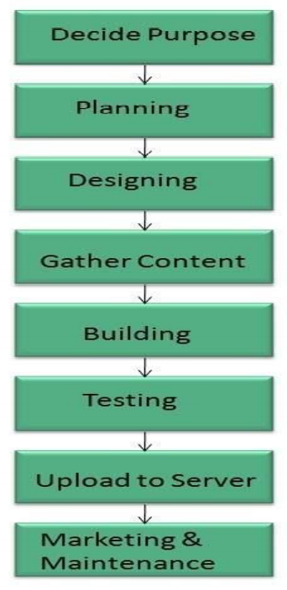

**Fig 1- Web Developing Process**

**1.3 Hardware Requirements:**

* Processor: i3 or above
* RAM: 4 GB or above
* Disc space: 20 GB (3 GB for database files + enough GB for shared documents, individual)
* Network card required

**1.3 Software Requirements:**

* Git package
* Visual Studio Code as IDE
* OPERATING SYSTEM: Windows 7
* DATABASE: MySQL or PostgreSQL
* FRONT-END: HTML, CSS, JAVASCRIPT, BOOTSTRAP4
* BACK-END: Java

**1.3 Testing technologies to be used:**

* Functionality Testing
* Usability testing
* Database Testing
* Compatibility testing
* Performance Testing
* Security testing
* Crowd Testing

**The Problem Statement**

* Some of the Medical Store owners can't be able to keep track of his stock detail’s which leads to an untimely shortage/loss of medicines or expiry of medicines.
* Some Medical Store owners won't give proper bills because they lack in time to make a handwritten bill for customers.
* Difficulty in managing a lot of medicines data/details.
* Difficulty in keeping track of medicines.
* Customers can't get a legal option if the exchange/return of the purchased medicine is not made by the store owner saying there is no bill.

**Objective**

In this project, we are going to make a website where medical store owners can log in to our site through their respective mobile numbers and can manage their database of products. Also, they can generate e –bills and print them.

* Design a system for better patient care.
* Provide top management a single point of control.
* Billing.
* Up-to-date factual information.
* Necessary for day-to-day tasks.
* Increase Awareness.

**Implementation Details**

* Firstly, we will make a log-in page for the user, the user can sign-up on our website through his mobile number & then log-in after completing the sign-up process.

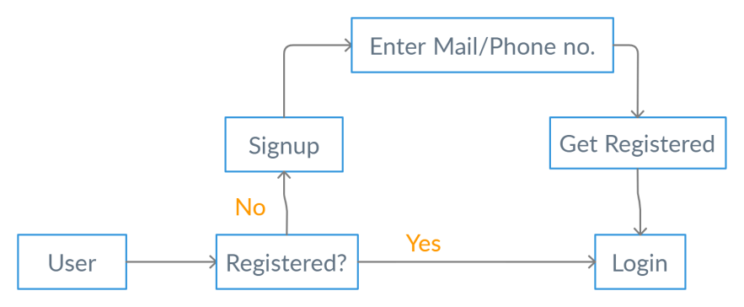

* After log-in into his account, user can get the option of adding medicine details into stock including details like quantity, price, expiry date, etc.

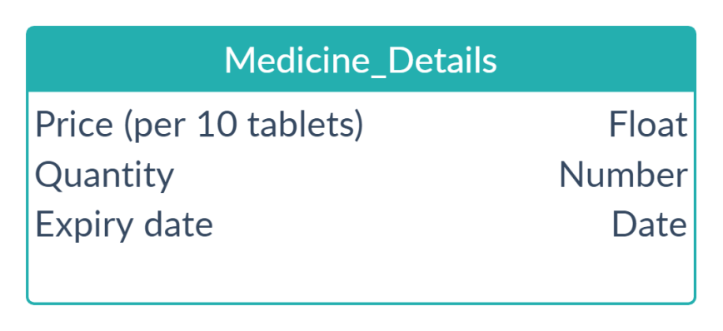

* He can also view the data of the stocks he has in his store so that there will be no untimely shortage/expiry of any medicine.
* He can also get a feature where he can type medicine name, quantity and can generate the bill for the customer.

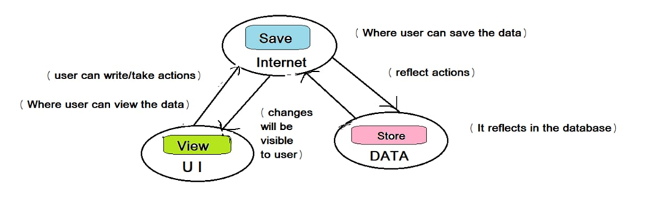

**Progress**

**Screenshots**

**References:**

[**https://hackr.io/tutorials/learn-bootstrap**](https://hackr.io/tutorials/learn-bootstrap)

[**https://www.learn-html.org/**](https://www.learn-html.org/)

[**https://bootstrapbay.com/blog/learn-bootstrap/**](https://bootstrapbay.com/blog/learn-bootstrap/)

[**https://www.w3schools.com/html**](https://www.w3schools.com/html)

[**https://www.udemy.com/html-css-bootstrap/**](https://www.udemy.com/html-css-bootstrap/)